INDEX

- Git Hub Configuration (Version Control Tools)

- Maven ( Build Tools)

DEVOPS:- The Communication between Development & Operations

- To Reduce communication gap between Development & Operations Devops comes under picture

- Devops is a Process

SDLC:- Software Development life cycle Methodologies
- Waterfall Model
- Agile Model
  - Description
It is based on iterative and incremental development, where requirements and solutions evolve through collaboration between cross-functional teams.

- Waterfall Model
  - Requirement Analysis
  - Design
  - Execution
  - Testing
  - Release

- Agile Model

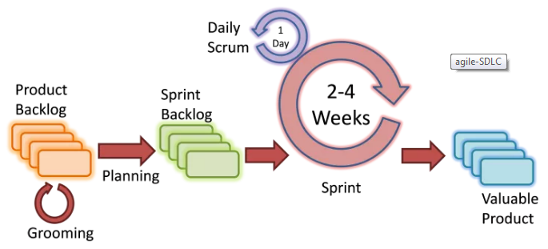

AJILE:- Ajile is a methodology
- In ajile methodology project will be spilited in to modules,

- Every release in Ajile is called as SPRINT Minimum time to release sprint is 2 Weeks, ( Sprint release will be changed bassed on organization requirements )

- In ajile their is no delay of work in between Developer and Testing team’s

CICD:- Continuous integration & Continuous deployment

DEVOPS Tools & Packages

Version Control Tools:-
- SVN
- GIT
- Big Bucket

Build Tools:-
- Ant
- Maven
- Nant
- Msbuild
- Gradel

Deployment Tools:-
- Tomcat
- Weblog
- Websphere

CICD:-
- Jenkins
- Bamboo
- Teamcity

Configuration Tools:-
- Chef
- Ansible

Working On Version Controls

- SVN

- GIT-HUB

Basic Commands of Git

- Using bellow commands we are providing basic info for git-hub using git-bash
  - git config –global user.name “varma”
  - git config –global user.email “xxxxxxx@gmail.com”

- Create a new local repository using following commands
  - git init

- Getting Remote repository data to local repository
  - git clone url of git hub or ssh of git hub

- Using following command’s we can add file to staging
- git add * for adding multiple files
- git add. For adding file with out file name
- git add filename For adding specific file

- Using following command we can change to head but not yet to the remote repository
  - git commit -m “First Sprint”

- Commit any files you've added with git add, and also commit any files you've changed since then
- git commit -a

- Send changes to the master branch of your remote repository:
  - git push origin master

- List the files you've changed and those you still need to add or commit
- git status

- If you haven't connected your local repository to a remote server, add the server to be able to push to it
  - git remote add origin <server>
- List all currently configured remote repositories
  - git remote -v

Creating Branch
- Creating a new branch and switch to it
  - git checkout -b <branchname>

- Switch from one branch to another
  - git checkout <branchname>

- List all the branches in your repo and also tell you what branches you’re currently in
  - git branch

- Delete the feature branch
  - git branch -d <branchname>

- Push the branch to your remote repository so others can use it
  - git push origin <branchname>

- Push all branches to your remote repository
  - git push -all origin

- Delete a branch on your remote repository
  - git push origin :<branchname>

Update from remote git-hub repository
- Fetch and merge changes on the remote server to your working directory
  - git pull

- To merge a different branch into your active branch
  - git merge <branchname> Ex:- sathya

- View all the merge conflicts
- View the conflicts against the basic file
- Preview changes before merging
  - git diff
  - git diff –base <filename> Ex:- sathya
  - git diff <source branch> <target Branch>

- After you have manually resolved any conflicts you mark the changed filename
  - git add <filename> Ex:- sathya

Tagging the Project

- You can user tagging to mark a significant changeset such as a release
  - git tab 1.0.0 <commitid>

- Commit ID is the leading characters of the changeset ID up to 10 but must be unique Get the ID Using
  - git log
- Push all tags to remote reposository
  - git push –tags origin

Undo local changes

- If you mess up you can replace the changes in your working tree with the last content in head changes already added to the index as well as news files will be kept
  - git checkout -- <filename>

- Instead, to drop all your local changes and commits, fetch the latest history from the server and point your local master branch at it, do this:
  - git fetch origin
  - git reset –hard origin/master

Search
- Search the working directory for foo():
  - git grep "foo()"

